**Tag Application**

**Brief Intro about Application**.

In this application mainly it contains Tagvalue to your post. Based on the Tag value we can display our posts related to tags like Facebook.

User entered posts should be uploaded into Database, When the user displaying the Posts, that posts retrieved from the Database. For that no one cannot change user posts.

If the user wants to delete the particular post, he can delete, if he click on remove button it will deleted from ui as well as from database also.

Every image contains ***remove button***.

This Application is developed by using HTML, CSS, Basic Angular

PHP.DatabaseMySQL and Tomcat server.

**Creation:**

**Project Structure:**

1)Created Project should be place in below location. Because i used XAMPP server.

**D:\Users\chodi.b\Pictures\Screenshots\prostr.png**

Place project in htdocs, my project name is phpimages, that’s why I kept phpimages folder in htdocs , like below snippet.

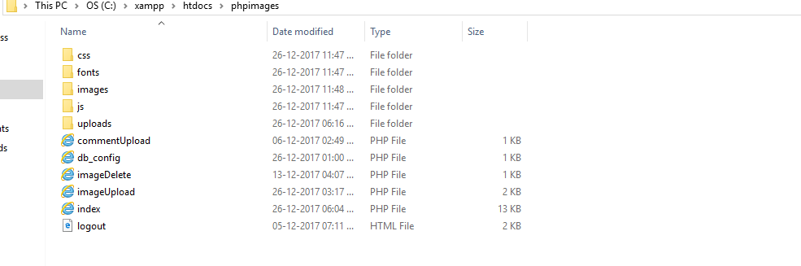

**2)Project UI Fildes:**

In our project User Interface Fields must be Title of the Post and Tag name related to your post and information related to your post in text field and post it may be a text file or image or world file can Upload.

As well Logout button is also there

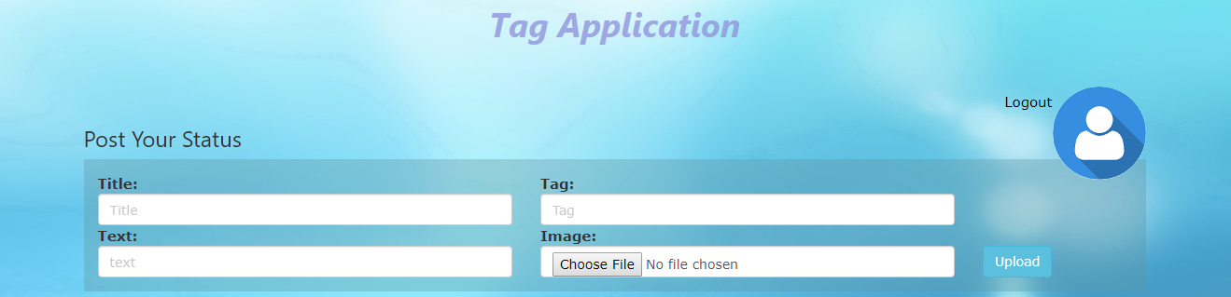

After that another important field ***Search Button*** for filter images and display based on the Tagvalue.



**3)Working of Application:**

After entering all the field values , if we press on **Upload** button then it will store in DataBase

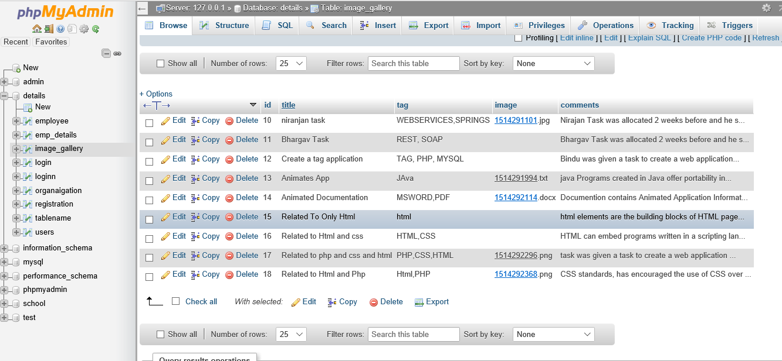

and display on the UI page

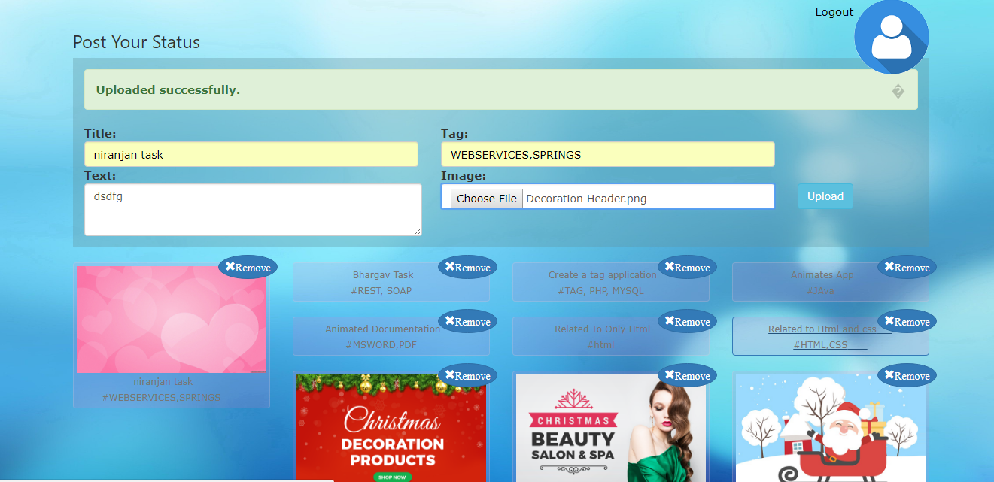

Our uploaded image or text file or Word document will be store in ***uploads folder***. This upload forder should be create by the developer in the project

This Upload Folder should be place like, shown in the Below snippet.

Xampp🡪htdocs🡪phpimages🡪uploads.

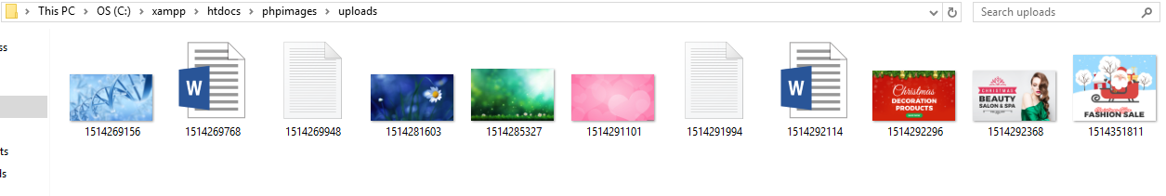

And if the user want to delete particular post, he can delete, for every uploaded image having the ***Remove*** button, if the user click on the remove button , it will delete from the UI display and as well as from database also.

See in the below picture , every image having ***Remove*** field.

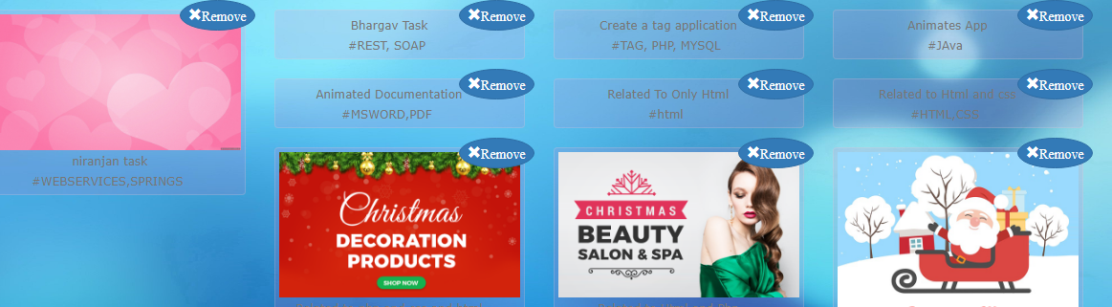

After that if the user wants particular upload, then based on Tag value we can filter posts.

Enter Tag Value in the Search field.

In below search button enter Tag value.



**Code Structure:**

Our Project name ***phpimages***

Xampp🡪htdocs🡪phpimages.

**index.php:**

In index page I used PHP for the connection and used HTML,CSS, and BOOTSTRAP for the front end.

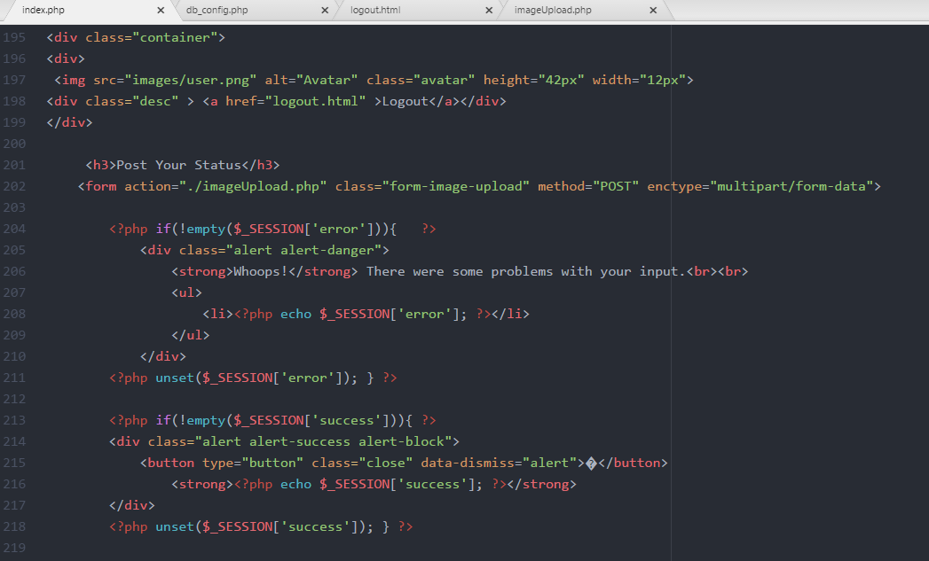

**imageUpload.php:**

In imageUpload file used PHP with database MySQL, it contains the image uploading database logic and that data is stores in the Uploads file.

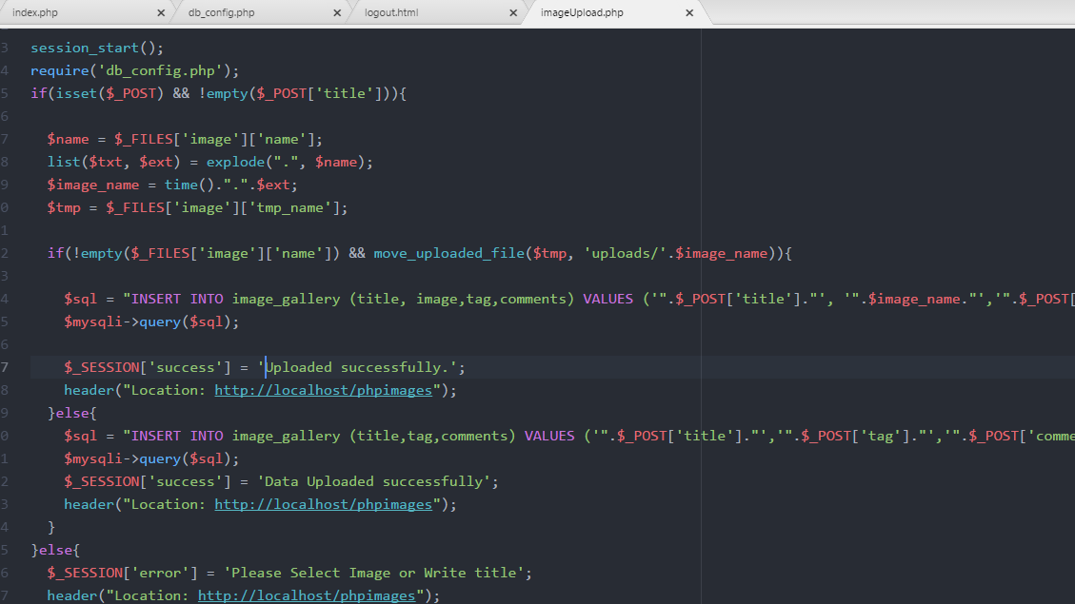

**db_config.php:**

In this file having only database information, like database name and user and host

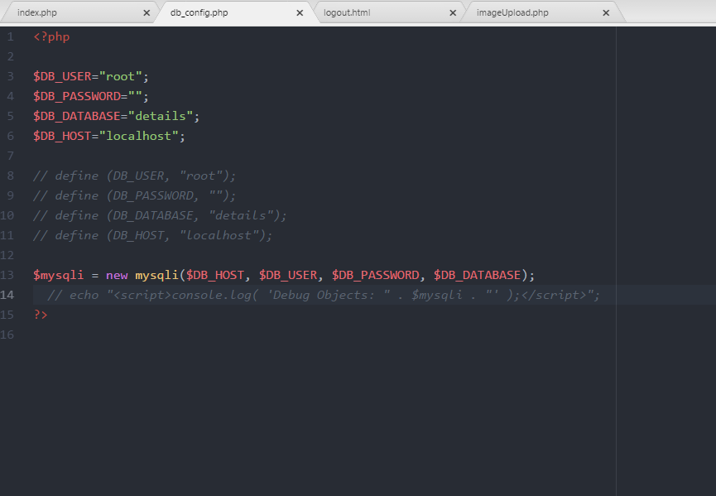

**imageDelete.php:**

In imageDelete file used PHP with database MySQL, it contains the image Deleting database logic and that data is deleted from the Database.

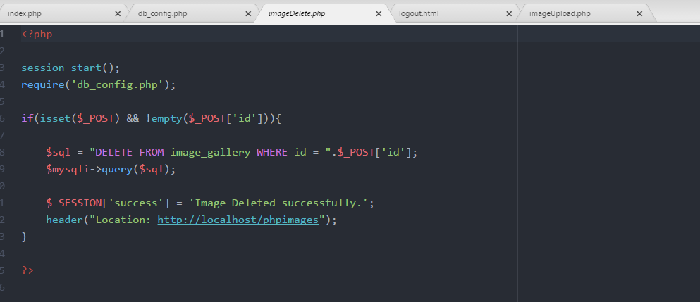

**Logout.html**

It Display the successfully logout text.



And place all your UI related predefined files in the project.

Like below

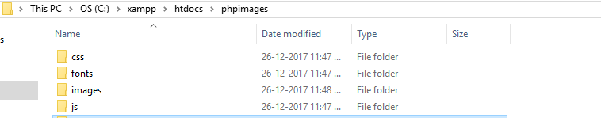

GitHub link:  <https://chodihimabindu.github.io/Tag-applicationPHP/>